|  |
| --- |
| <PROJECT NAME> Executive Summary |
| Group Member Names William Crane, Zak Cobham-Davis, Christopher Linnett 2810ICT Software Technologies Assignment, Part B Date 4/10/2022 |

# Abstract

This report reviews the graphical functionality of the New South Wales (NSW) Traffic Penalty Data by analyzing the crash data over a 12-month period. Specifically, the graphs have been set for a period between January 2013 and January 2014 and are utilizing workbooks, bar graphs and line graphs to visualize the data. Moreover, this information can be accessed and utilized for user and purpose driven data, to indicate a clear trend over a specific time period through the Functioning GUI. Furthermore, screenshots of the data have been Supplied to review the functioning data and GUI.

# Introduction

The purpose of this report is to present the results of the Data Analysis Tool GUI, Implemented in Part B. The graphs review the functionality of the NSW Traffic Penalty Database between January 2013 and January 2014. Each function and report type will be analyzed within this report, specifically, ‘All Offences’, ‘All Offences Involving Radar/Camera’, ‘Distribution of all Offence Codes’, ‘Monthly Trend of all Offences’ and the fifth analysis reviews Limiting the Data to Mobile Phone Usage which can be applied to any of the other functions, there data groups and graphical view.

# Analysis

## Analysis 1 <Distribution of all Offence Codes Between January 2013 and January 2014>

Figure one Displays the Distribution of Offence Codes and Their Quantity Between January 2013 and January 2014. The Bar Graph displays a simple X and Y Axis and is Utilizing the Tkinter Package to Display the Graphical Information.

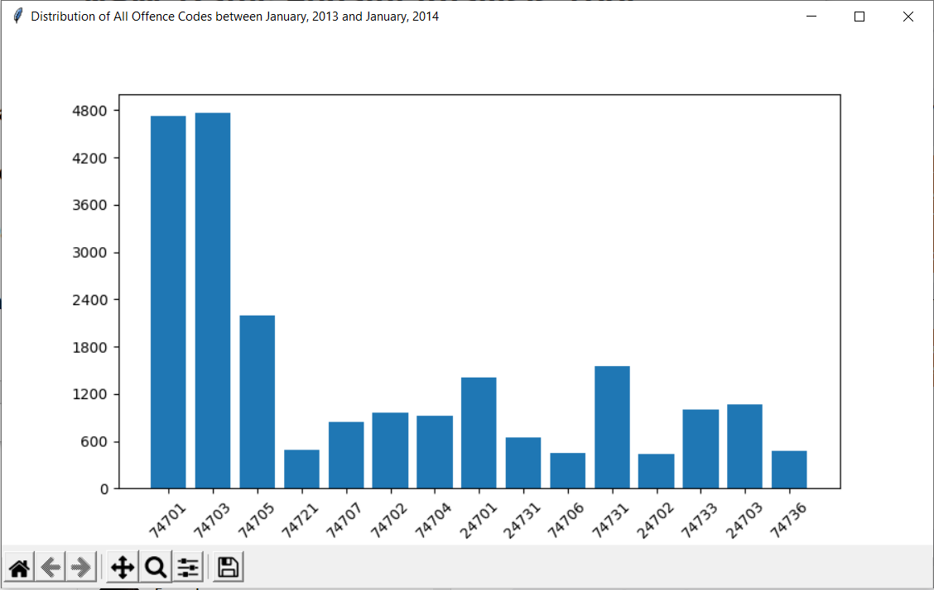  
(Figure 1)

Analysis 2 <Monthly Trend of all Offences Between January 2013 and January 2014>

Figure 2 Displays a Line Graph that is Analyzing the Monthly Trend of all offences between January 2013 and January 2014. This Graph has been plotted on a Simple X and Y Axis utilizing the Tkinter Package, the Y axis for this reporting method is evaluating Quantity while the X axis is Labelled utilizing time. 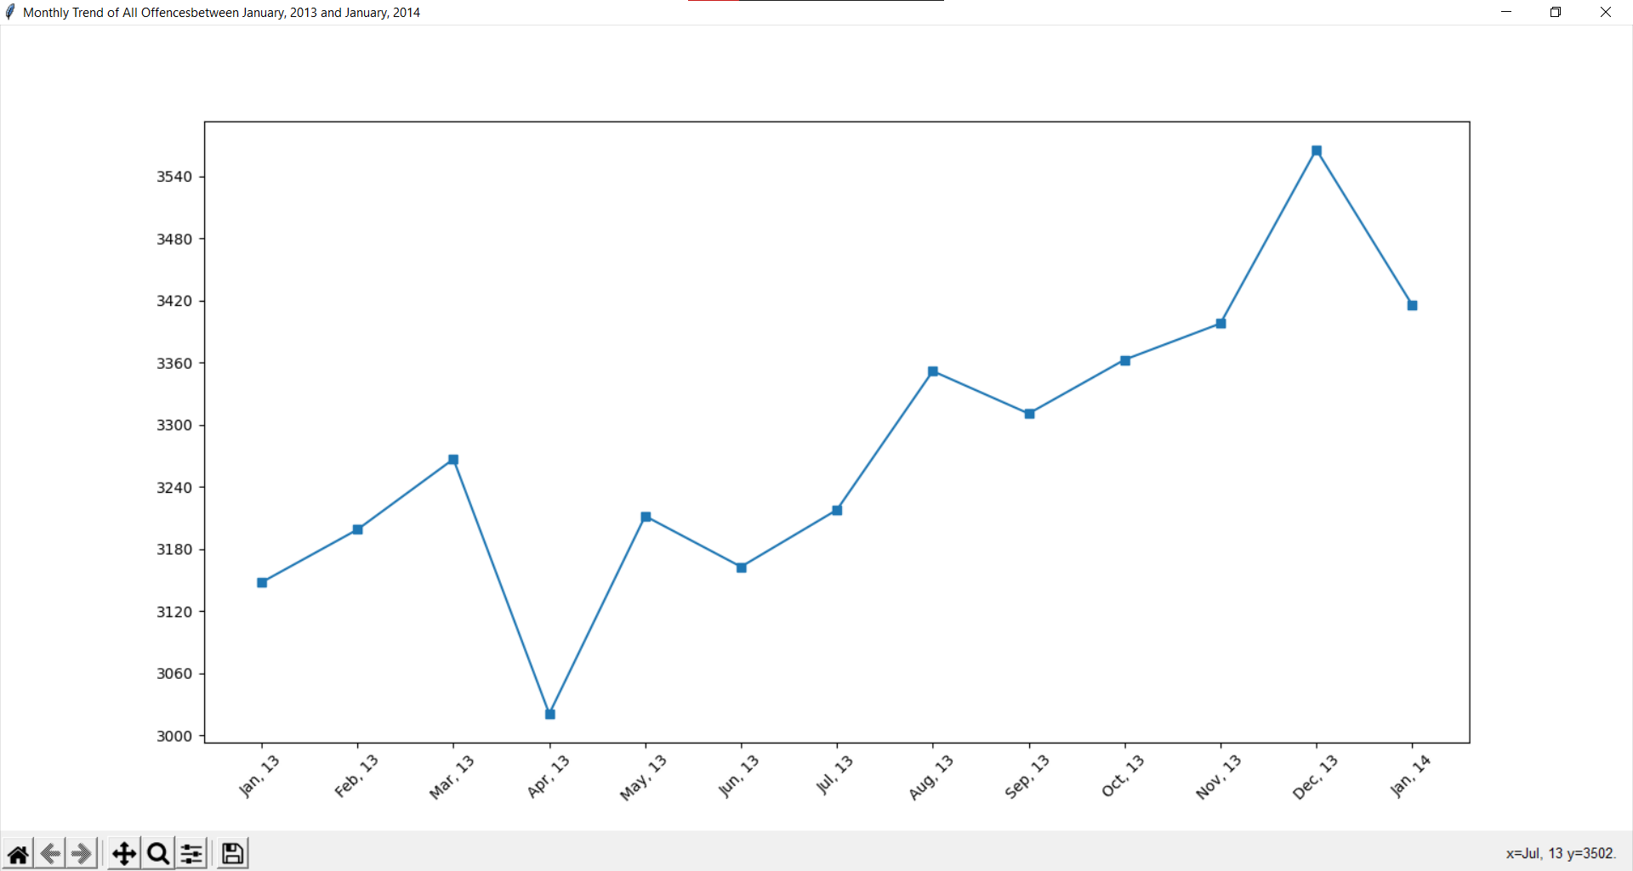  
(Figure 2)

Analysis 3 <All Offences Involving Radar/Camera Between January 2013 and January 2014> Figure 3 Displays All Offences Involving Radar/Camera between January 2013 and January 2014, the graphical interface has utilized Tkinter to display this functional report type via a workbook method, it is drawing the information straight from the workbook to display it, there is no conversion that would generally occur with the line or bar graph. 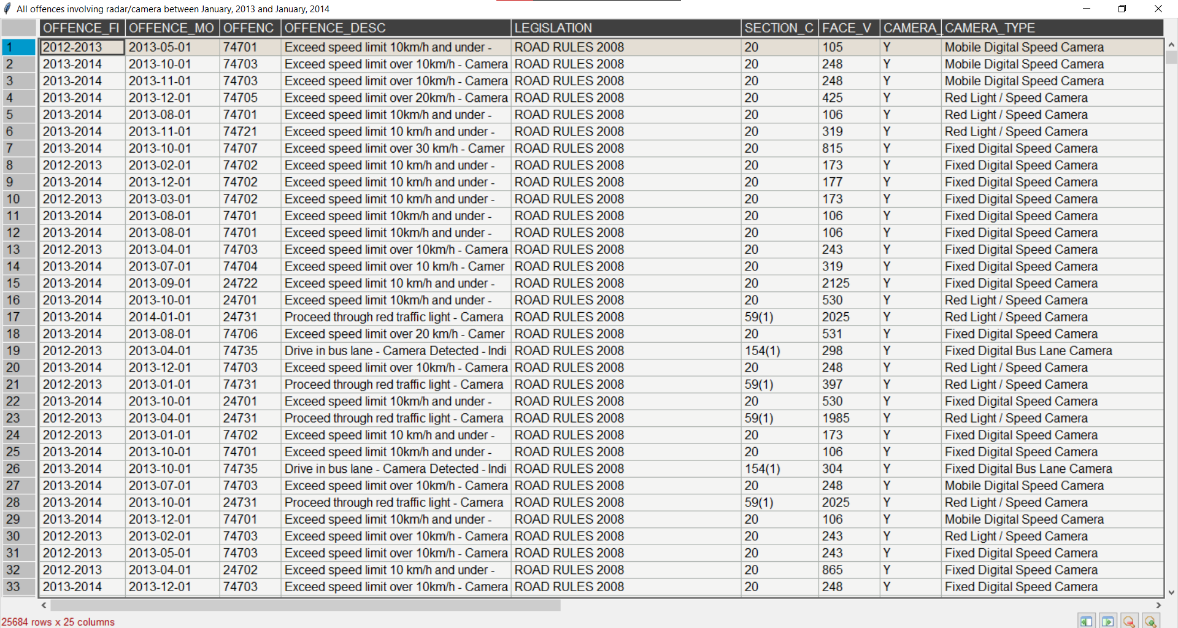  
(Figure 3)

Analysis 4 <All Offences Between January 2013 and January 2014> Figure 4 Displays All Offence between January 2013 and January 2014, the graphical interface has utilized Tkinter to display this functional report type via a workbook method, it is drawing the information straight from the workbook to display it, there is no conversion necessary that would occur with the bar or line graph.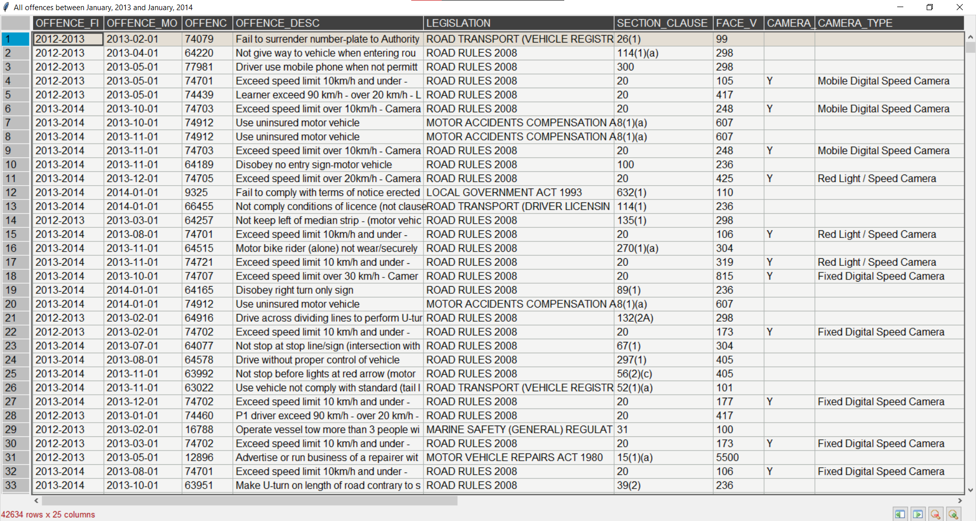

(Figure 4)

## Analysis 5 <Data Limited to Mobile Phone Usage >

Figure 5.1, 5.2, 5.3, 5.4 has been developed utilizing the option button to limit data to mobile phone infringements, this limits the data retrieved from the workbook to only Penalties that have occurred with mobile phone usage. This functional implementation only impacts the data not the view of the Graph provided by the GUI, so the graphs remain the same. This is seen most clearly in Figure 5.4 and as no Mobile Phone Usage can occur within the ‘All Offences Involving Radar/Camera Between January 2013 and January 2014’ report category. This reporting method is the custom implementation required within the Assignment.

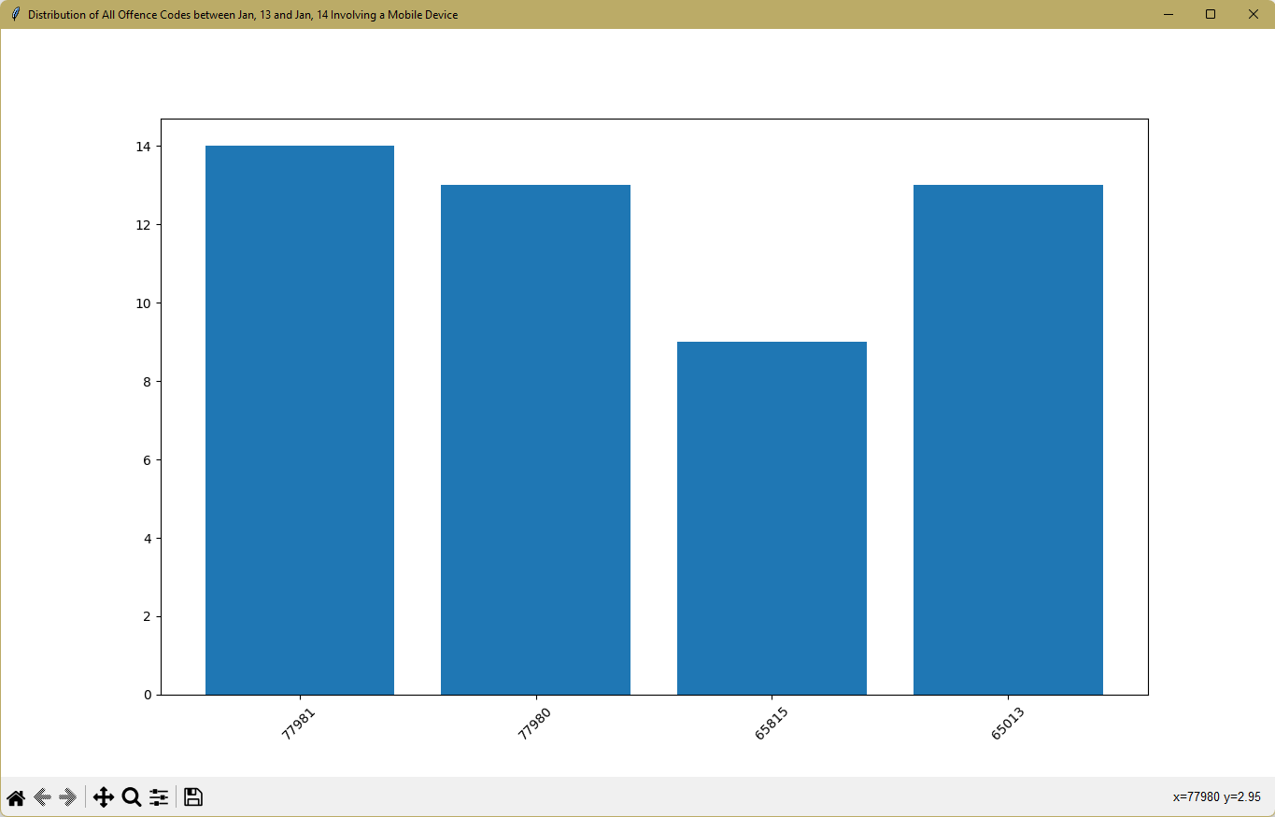(Figure 5.1)

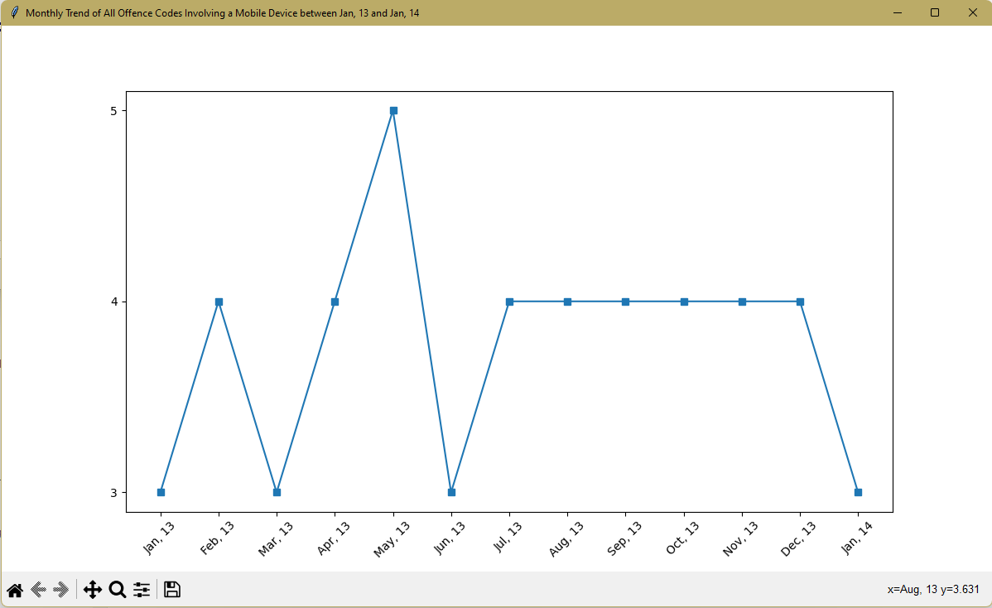(Figure 5.2)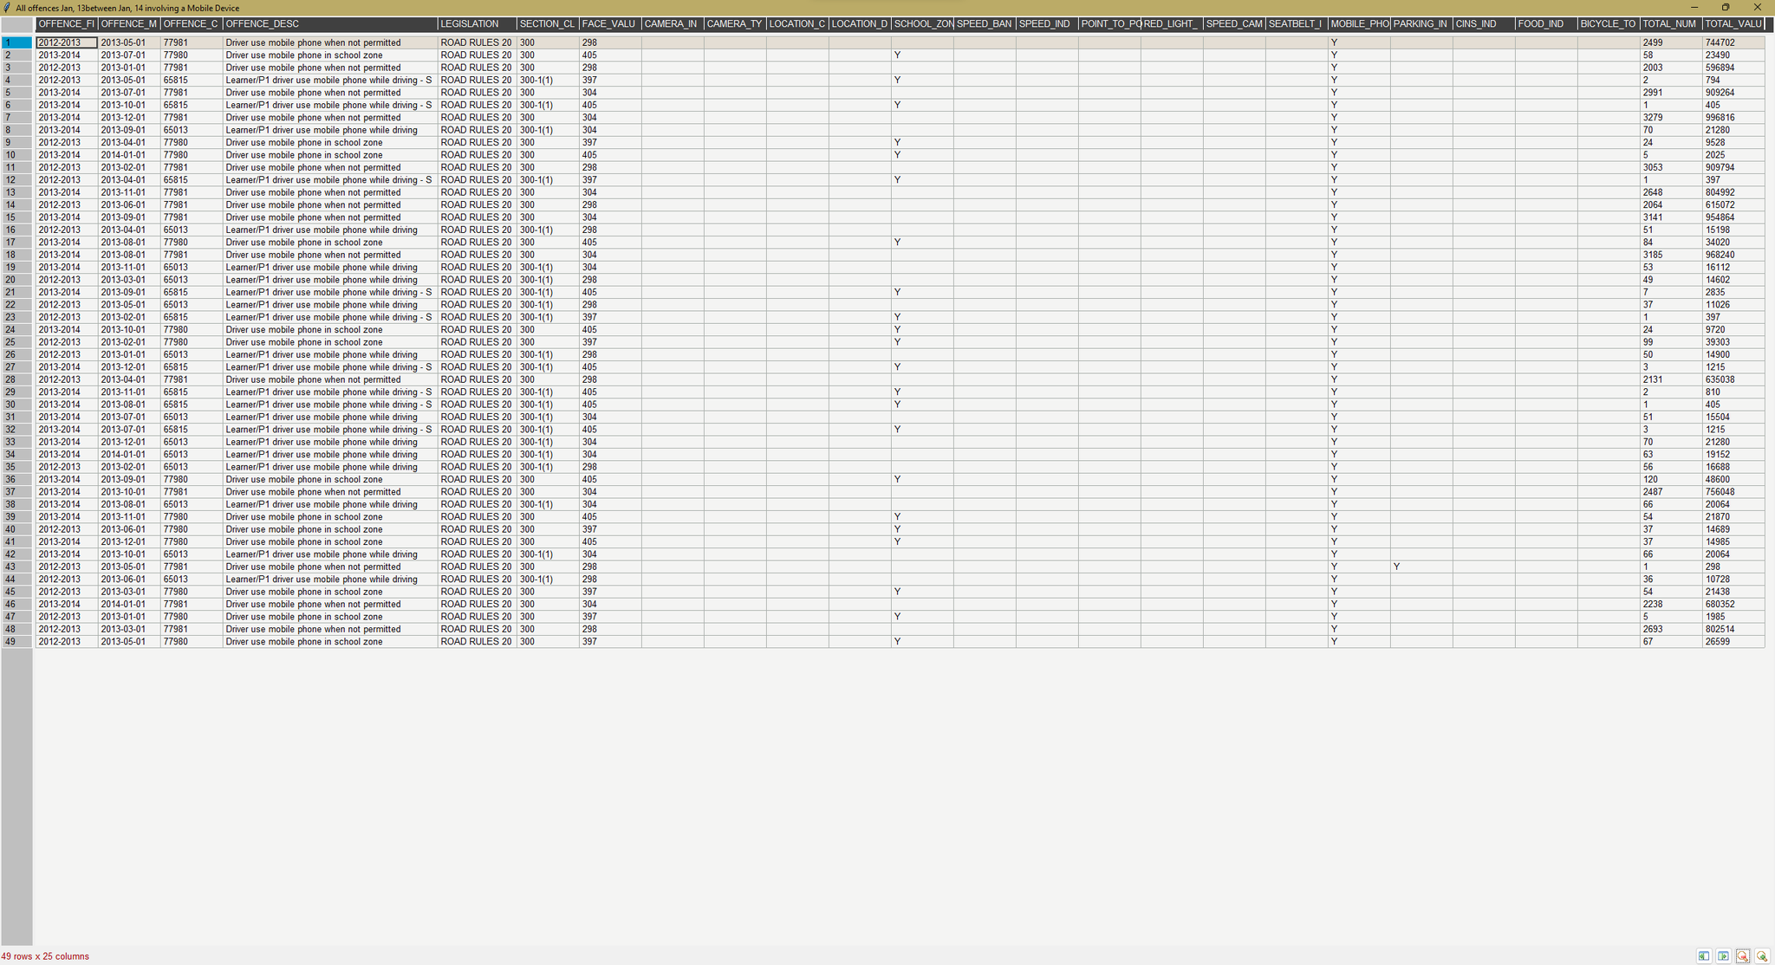(Figure 5.3)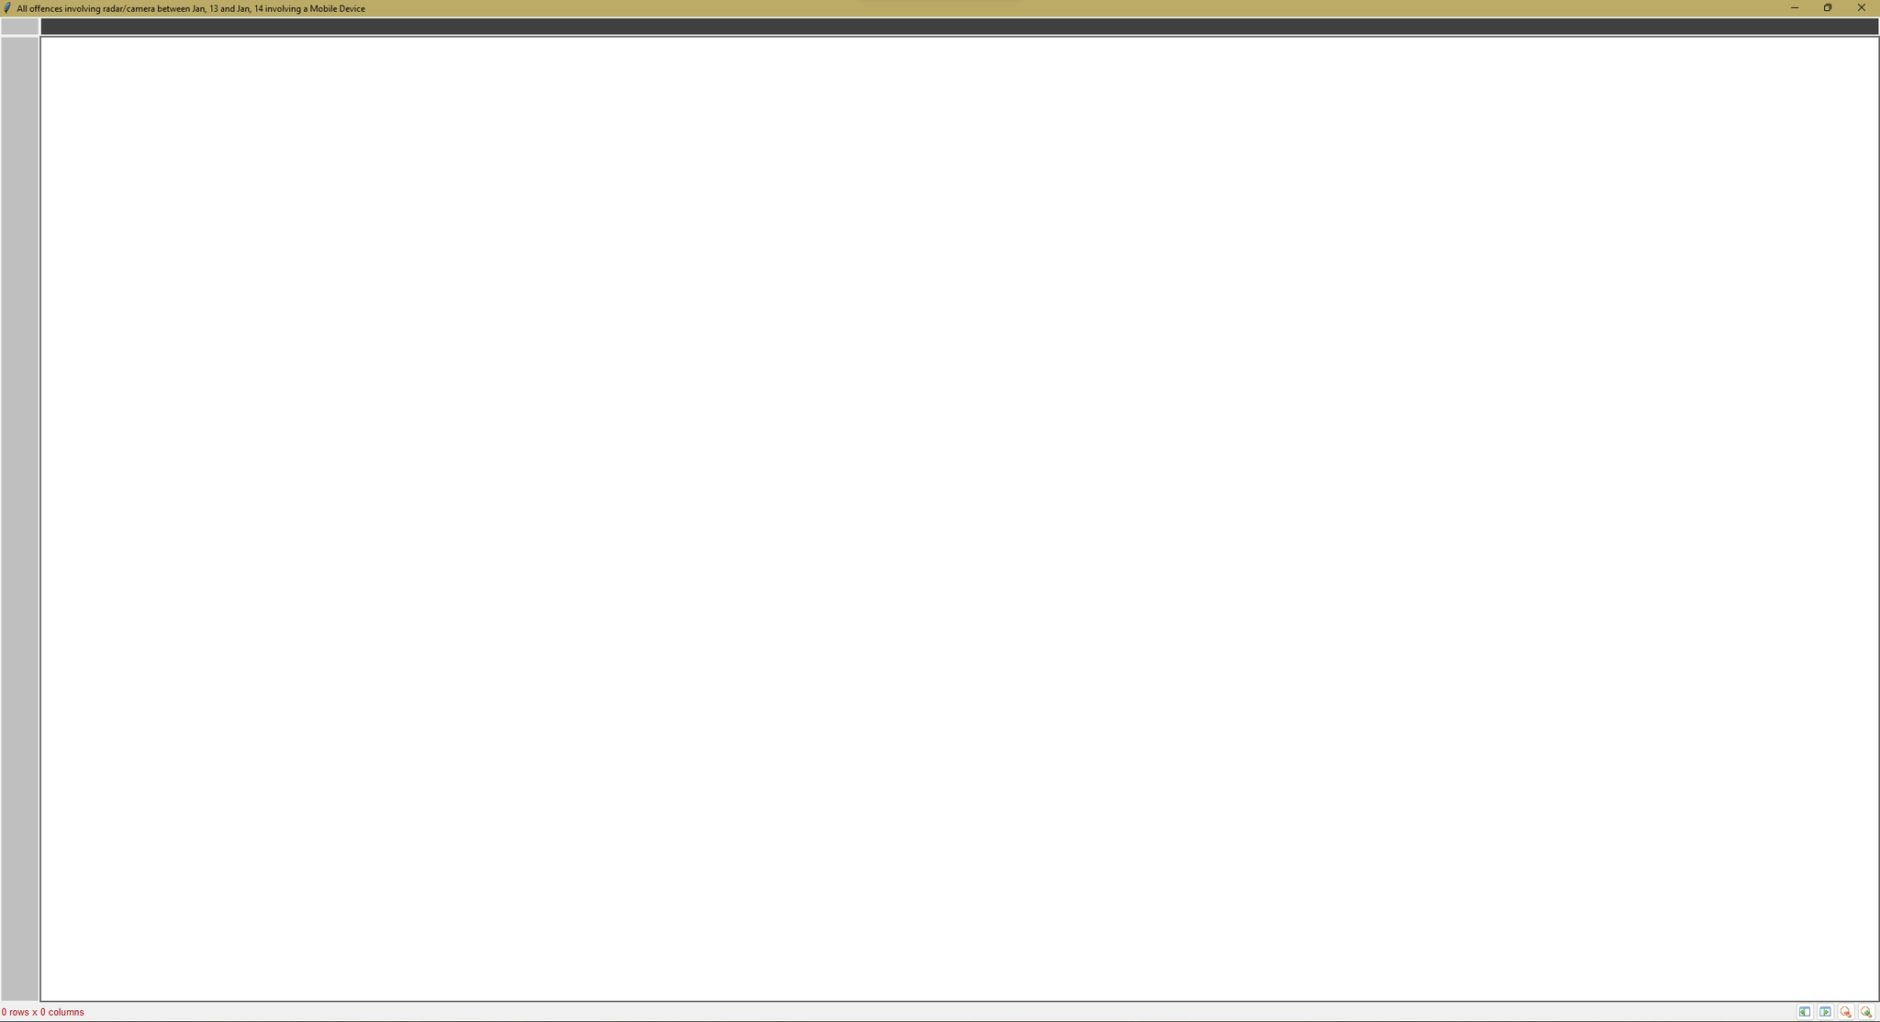(Figure 5.4)